EduTrack
Enterprise Student Record & Academic Management Platform
Unit-1 Mini Project | Design Thinking & Product Planning

1. Introduction & Business Understanding
EduTrack is a planned academic management platform for a higher-education institution. It focuses on understanding the academic domain, users and requirements before coding, and centralizes student records and academic information.

Problem Statement
Manual or scattered academic records can create duplicate data, slow searching, attendance errors, difficult result preparation and delayed reports. EduTrack proposes one structured platform for registration, records, attendance, examinations, results and reports.

Project Objective
• Understand admissions, course registration, attendance, examination and result workflows.
• Identify stakeholder needs and manual-record problems.
• Apply Design Thinking before implementation.
• Prepare requirements, product vision, MVP, roadmap and architecture.
• Create a foundation ready for Agile development.

Target Users
User | Main Need
Student | Profile, attendance, examination and academic reports.
Faculty | Attendance, academic records and results.
Academic Administrator | Student information and reports.
Examination Staff | Examination and result information.
IT Support | Access, security and reliability.

2. Design Thinking & IBM Design Thinking
Human-Centered Product Planning

Five Stages of Design Thinking
Stage | EduTrack Application
Empathize | Understand students, faculty, administrators and examination staff.
Define | Define the need for a centralized, user-friendly academic platform.
Ideate | Central database, attendance, result management, dashboards and reports.
Prototype | Login, Dashboard, Registration, Student List, Attendance, Examination, Results and Reports.
Test | Users perform tasks; observe navigation, collect feedback and refine.

IBM Design Thinking Principles
• Focus on User Outcomes – easier access, simpler attendance and faster reports.
• Restless Reinvention – continuously improve workflows using feedback.
• Diverse Empowered Teams – product, UI/UX, development, testing, database and support collaborate.

IBM Loop: Observe → Reflect → Make
Loop | Activity
Observe | Study academic workflows and collect feedback.
Reflect | Identify pain points and prioritize requirements.
Make | Improve screens, requirements and product design; repeat.

Core Problem Statement
Students and academic staff need a centralized way to manage records, attendance, examinations, results and reports because scattered or manual processes can make academic information difficult to maintain, search and update.

3. Stakeholders, Personas & Requirements
Who uses the system and what do they need?

Stakeholder Analysis
Stakeholder | Role | Expectation
Students | Academic service users | Easy access to profile, attendance, results and reports.
Faculty | Academic record management | Fast attendance and result entry.
Academic Administrators | Institution management | Centralized records and reports.
Examination Cell | Exam/result operations | Correct exam and result information.
IT Support | Technical support | Security, availability and maintainability.

User Personas
Persona | Goals | Pain Points
Student | Check academic information quickly. | Searching records or waiting for reports.
Faculty | Record data accurately. | Repeated manual entry.
Administrator | Manage records and reports. | Duplicate data and slow reporting.

Functional Requirements (FRS)
• FR-01 Authentication and role-based access.
• FR-02 Student Registration.
• FR-03 Student Record Management.
• FR-04 Course/Subject Management.
• FR-05 Attendance Management.
• FR-06 Examination Management.
• FR-07 Result Management.
• FR-08 Academic Report Generation.
• FR-09 Dashboard.
• FR-10 Search/View Records.

Non-Functional Requirements (NFRS)
• Security
• Usability
• Reliability
• Performance
• Scalability
• Maintainability

4. Product Vision, MVP & Data Flow Diagram
From user needs to the first usable release

Product Vision
To provide a centralized, user-friendly and reliable academic management platform that simplifies student records, attendance, examinations, results and academic reporting.

Mission
Reduce manual academic record-management effort and give users structured access to relevant academic information.

Minimum Viable Product (MVP)
• Student Registration
• Student Record Management
• Attendance Management
• Academic Report Generation

Data Flow Diagram – Level 0
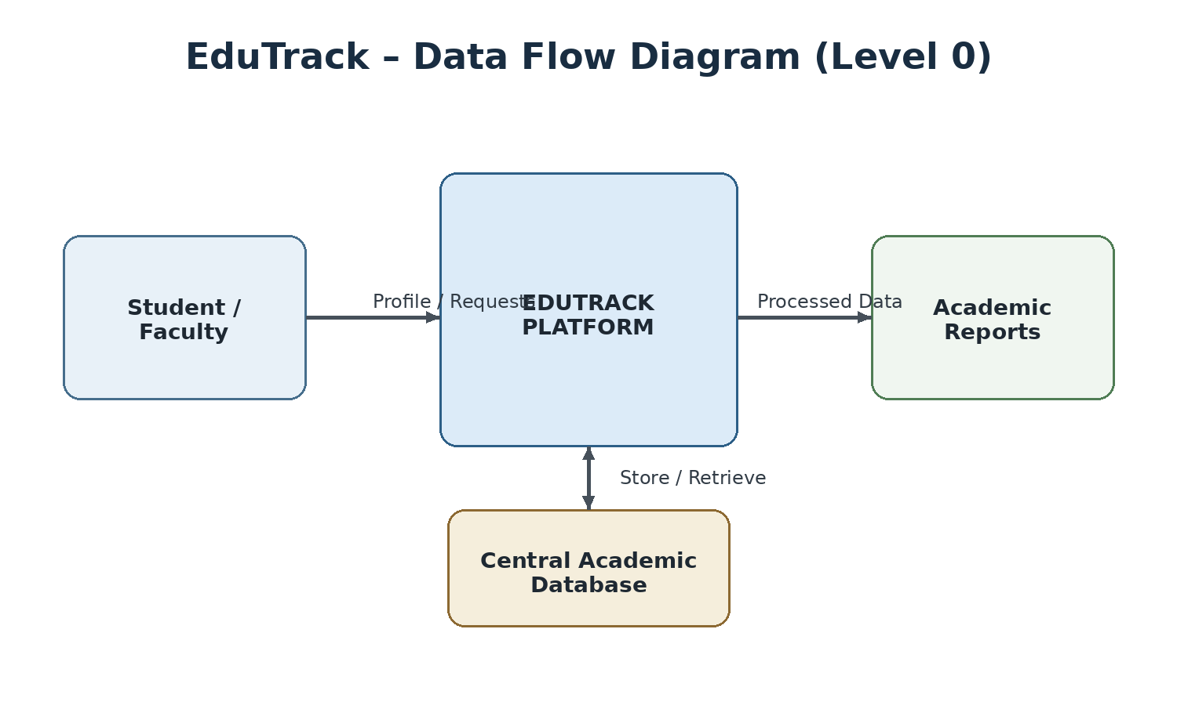
Figure 1: EduTrack Data Flow Diagram
The DFD shows users sending academic information to EduTrack, the platform processing it, storing it in the central academic database, and producing authorized academic reports.

5. System Architecture, Data Model & Roadmap
Technical planning before implementation

Initial System Architecture
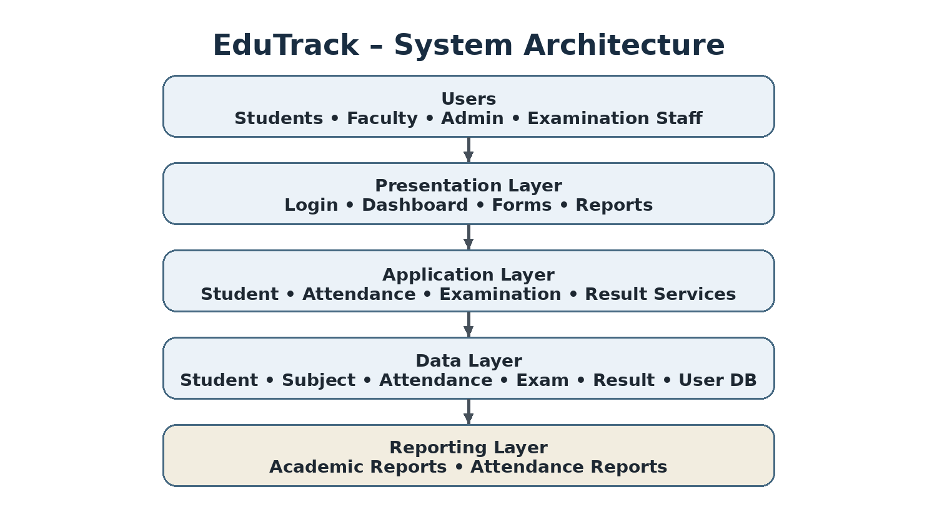
Figure 2: EduTrack Initial System Architecture

Initial Data Model
Entity | Important Attributes
Student | student_id, name, DOB, contact, course, department, semester
Course/Subject | subject_id, subject_name, course, semester
Attendance | attendance_id, student_id, subject_id, date, status
Examination | exam_id, exam_name, subject_id, date
Result | result_id, student_id, exam_id, marks, grade
User | user_id, username, role

Product Roadmap
Phase | Focus
1 | Domain analysis & problem understanding
2 | Design Thinking & prototyping
3 | Requirements planning – BRD, FRS, NFRS, MVP
4 | System architecture & database design
5 | Core application development
6 | Testing, feedback & improvement

6. Project Charter, Repository, Testing & Future Scope
Project execution foundation

Project Charter
Item | Details
Project | EduTrack
Domain | Education / Academic Management
Goal | Centralized student and academic record management
Users | Students, Faculty, Administrators, Examination Staff
MVP | Registration, Records, Attendance, Academic Reports
Methodology | Design Thinking; Agile-ready planning

Repository / Folder Structure
EduTrack/
├── docs/ → BRD, FRS, NFRS, Personas, Roadmap, Architecture
├── src/ → Application source code
├── database/ → Database schemas/scripts
├── tests/ → Test cases
├── README.md
└── PROJECT-CHARTER.md

Initial Test Plan
ID | Test Case | Expected Result
T-01 | Valid login | Dashboard opens.
T-02 | Invalid login | Access rejected.
T-03 | Register student | Record stored.
T-04 | Search student | Matching record displayed.
T-05 | Mark attendance | Attendance saved.
T-06 | Enter result | Correct student/exam linked.
T-07 | Generate report | Academic report produced.

Future Scope
• Timetable
• Notifications
• Online examination
• Advanced analytics
• Mobile application
• Cloud deployment
• Institutional integrations
7. Product Discovery, Conclusion & References
Classic final submission page

Product Discovery Questions
• Who uses student academic records?
• What information does each role need?
• Which activities are manual?
• Which features are essential for MVP?
• What security and usability expectations exist?
• How will feedback be collected and used?

Key Insights
• Different roles need different access and workflows.
• Student information should be centralized.
• Attendance and examination/result records are core data.
• MVP should focus on essentials.
• Feedback should guide prototype improvements.

Project Conclusion
EduTrack is a planned Student Record and Academic Management Platform developed through a human-centered product-engineering approach. Unit-1 begins with business understanding and stakeholder needs, applies Design Thinking and IBM Design Thinking, defines requirements, identifies the MVP, prepares a roadmap, and proposes architecture and repository structure. The project is ready for subsequent Agile planning and development.

References
1. Unit-1 Mini Project brief: Enterprise Student Record and Academic Management Platform – Design Thinking and Product Planning, trainer-provided document.
2. DevOps Unit-1 Mini Project Guide: Training & Technical Project Document – Product Engineering & Design Thinking, trainer-provided reference document.
3. IBM Design Thinking concepts: Focus on User Outcomes, Restless Reinvention, Diverse Empowered Teams and Observe → Reflect → Make cycle, as referenced in the provided guide.
4. Course/trainer notes and classroom discussions on Design Thinking, requirements engineering, MVP and product planning.
Classic flow: Understand → Empathize → Define → Ideate → Prototype → Test → Plan → Build

Appendix A: Detailed Business Analysis
Expanding the business understanding of EduTrack

A.1 Existing Situation
In an academic institution, student information is used by several departments during admission, course registration, attendance, internal assessment, examinations and result preparation. When information is maintained in separate registers or files, staff may need to enter the same information more than once. This can create inconsistent records and make it difficult to identify the latest, correct version.
EduTrack is planned as a centralized platform. The purpose of this Unit-1 proposal is to understand the problem and design the product before implementation. The document describes a proposed system; it does not claim that a production application has already been deployed.

A.2 Business Needs
Business need | Why it matters | Proposed response
Single source of student information | Reduces repeated entry and conflicting versions | Central student record with a unique student ID
Faster retrieval | Staff and students need timely access | Search and filter records
Consistent attendance records | Attendance must be associated with student, subject and date | Attendance module linked to student and subject
Organized examination data | Exam records and marks must be traceable | Examination and result records linked through IDs
Useful reporting | Authorized staff need summaries and lists | Report generation based on stored records
Controlled access | Not every user should view or edit every record | Authentication and role-based permissions

A.3 Proposed Scope
- In scope for the first release: student registration, student records, attendance and basic academic reports.
- Planned supporting capabilities: login, role-based access, dashboard and record search.
- Outside the initial MVP: online examinations, advanced analytics, cloud deployment and integrations. These remain future-scope possibilities.
- Final rules, data fields and permissions should be confirmed with the institution's stakeholders before development.

Appendix B: Academic Workflows and Use Cases
How users may interact with the proposed platform

B.1 Student Registration Workflow
- An authorized administrator opens the registration screen.
- The administrator enters the student's identifying and academic details.
- The system checks required fields and validates the data format.
- The system checks whether a student ID or other unique identifier already exists.
- If validation succeeds, the record is saved to the academic database.
- The system displays a confirmation and makes the record available for authorized search.

B.2 Attendance Workflow
- Faculty selects a subject, class or semester and attendance date.
- The system displays the relevant student list.
- Faculty marks each student's attendance status.
- The system validates that the selected subject and date are present.
- Attendance is saved with links to the student and subject records.
- Authorized users can view attendance summaries or generate a report.

B.3 Examination and Result Workflow
- Examination staff creates an examination entry and associates it with a subject.
- Marks are entered for the relevant students after assessment.
- The system validates allowed mark ranges and required links.
- Results are saved against the correct student and examination.
- Authorized staff review the data and generate result reports.

B.4 Example Use Cases
Use case | Primary actor | Expected outcome
Log in | Student / Faculty / Admin | Authorized dashboard opens
Register student | Administrator | Validated student record is stored
Mark attendance | Faculty | Attendance is saved for the chosen class and date
View result | Student or authorized staff | Relevant result is displayed according to permissions
Generate report | Administrator / Examination staff | Report is prepared from stored academic data

Appendix C: Expanded Requirements Specification
Functional and quality requirements

C.1 Functional Requirements with Details
ID | Requirement | Acceptance indication
FR-01 | Authentication and role-based access | Valid credentials allow access; unauthorized access is rejected
FR-02 | Student registration | Required fields are checked and a valid record can be saved
FR-03 | Student record management | Authorized staff can view and update permitted student fields
FR-04 | Course/subject management | Subject information can be maintained and linked to academic records
FR-05 | Attendance management | Attendance can be recorded for a student, subject and date
FR-06 | Examination management | Examination details can be created and retrieved
FR-07 | Result management | Marks and grades are linked to the correct student and examination
FR-08 | Academic report generation | A report can be generated from available, authorized records
FR-09 | Dashboard | The user sees useful options according to their role
FR-10 | Search/view records | A user can search using supported fields and see matching records

C.2 Non-Functional Requirements Explained
- Security: protect accounts and restrict access to authorized roles; sensitive information should not be exposed to unrelated users.
- Usability: labels, navigation and forms should be understandable to first-time users.
- Reliability: saved records should remain consistent, and errors should be communicated clearly.
- Performance: common operations such as searching and opening a record should respond in a reasonable time under expected use.
- Scalability: the design should allow the number of students, subjects and academic records to grow.
- Maintainability: code, database design and documentation should be organized so that future changes can be made safely.

C.3 Validation Rules to Confirm
Before implementation, stakeholders should confirm required fields, permitted formats, duplicate-record rules, attendance status values, maximum marks, grading rules, retention.
Appendix D: Data Design and Information Security
Proposed data relationships and responsible handling

D.1 Main Entities
Entity | Example attributes | Purpose
Student | student_id, name, DOB, contact, course, department, semester | Stores student profile and academic affiliation
Course/Subject | subject_id, subject_name, course, semester | Stores subjects offered in a course or semester
Attendance | attendance_id, student_id, subject_id, date, status | Records attendance for a student and subject
Examination | exam_id, exam_name, subject_id, date | Stores examination information
Result | result_id, student_id, exam_id, marks, grade | Stores student performance for an examination
User | user_id, username, role | Identifies a platform account and its role

D.2 Relationship Notes
- A student may have many attendance records over time.
- A subject may have attendance records for many students and dates.
- A subject may be associated with multiple examinations.
- A student may have a result record for each relevant examination.
- Foreign-key relationships should be used where supported by the chosen database so that records cannot accidentally point to nonexistent students, subjects or examinations.

D.3 Security and Privacy Practices
- Collect only information required for academic purposes.
- Use secure password storage rather than storing readable passwords.
- Apply role-based authorization on the server or trusted application layer, not only by hiding screen buttons.
- Validate data on submission and handle unexpected input safely.
- Limit access to reports containing personal information.
- Plan regular backups and test whether data can be restored.
- Keep an audit trail for important changes where institutional policy requires it.
- Use a defined process for correcting errors and disabling accounts when access is no longer needed.
The exact legal, institutional and technical controls must be confirmed during detailed design. This Unit-1 report presents planning recommendations, not a security certification.

Appendix E: Interface Planning and Accessibility
Proposed screens and user experience considerations

E.1 Initial Screen Plan
Screen | Main elements | Design consideration
Login | Username, password, sign-in action, error message | Clear feedback; avoid revealing sensitive account details
Dashboard | Role-specific summary and navigation | Show important actions without overcrowding
Student Registration | Student fields, validation, save/cancel | Group related fields and mark required items
Student List | Search, filters, record summary | Make search results easy to scan
Student Details | Profile and academic information | Separate view from edit actions where useful
Attendance | Subject/date selection and student list | Reduce accidental marking and support review before saving
Examination / Results | Exam selection, marks and grade details | Validate ranges and clearly identify the student and exam
Reports | Report filters, preview and export/print option | Show the selected date, class or subject clearly

E.2 Usability Guidelines
- Use consistent terms for student ID, subject, semester and attendance status throughout the system.
- Provide a clear success message after saving and a specific message when validation fails.
- Preserve entered information when a correctable validation error occurs, where practical.
- Use readable text, sufficient contrast and controls that are easy to select.
- Do not rely on colour alone to communicate status; include text labels or symbols.
- Keep navigation predictable and provide a way to return to the previous screen.
- Test the interface with students, faculty and administrators because their tasks differ.

E.3 Prototype Feedback Questions
- Can the user identify the next action without help?
- Are form labels understandable?
- Can users find a student record quickly?
- Is it clear which records are saved and which are not?
- Do error messages explain how to correct the problem?
- What information is missing from the dashboard or report?

Appendix F: Agile Plan, Testing and Risk Management
Moving from product planning toward implementation

F.1 Suggested Agile Backlog
Priority | Backlog item | Definition of done
High | Login and role permissions | Valid and invalid access paths are tested
High | Student registration | Valid data saves; missing and duplicate data are handled
High | Student record search | Matching records display and no-match cases are clear
High | Attendance entry | Attendance is saved against correct student, subject and date
Medium | Basic academic reports | Report fields and filters are checked against stored records
Medium | Dashboard | Relevant options appear for each role
Later | Notifications and mobile app | Requirements and delivery approach are assessed
Later | Analytics and integrations | Data quality, privacy and institutional needs are evaluated

F.2 Testing Approach
- Functional testing: verify that each requirement works as described.
- Validation testing: try missing fields, invalid formats, duplicate IDs and out-of-range marks.
- Access-control testing: confirm that users cannot open or change data outside their role.
- Integration testing: confirm that attendance and results link to the correct student and subject/examination.
- Usability testing: ask representative users to complete common tasks and observe difficulties.
- Regression testing: after a change, rerun tests for features that could be affected.

F.3 Risk Register
Risk | Possible impact | Mitigation idea
Incomplete requirements | Rework and missed features | Interview stakeholders and review requirements before coding
Duplicate or incorrect data | Unreliable records and reports | Validation, unique identifiers and review procedures
Unauthorized access | Exposure or modification of records | Role permissions, secure authentication and testing
Low user adoption | Users continue using separate manual records | Simple interface, training and feedback-based improvements
Schedule overrun | MVP delayed | Prioritize essential features and deliver in small increments
Data loss | Academic information becomes unavailable | Backups, restore tests and controlled database changes

F.4 Review Cycle
At the end of each development increment, the team should demonstrate the working feature, collect feedback, update the backlog and agree on the next priority. This supports the Observe → Reflect → Make loop and keeps product decisions connected to actual user needs.

Appendix G: Project Deliverables and Extended Conclusion
Checklist for a complete Unit-1 submission

G.1 Expected Planning Deliverables
- Business problem and project objectives.
- Stakeholder analysis and user personas.
- Design Thinking stages and IBM Design Thinking principles.
- Functional and non-functional requirements.
- Product vision, mission and minimum viable product.
- Level-0 Data Flow Diagram and initial system architecture.
- Initial entity/data model and product roadmap.
- Project charter, repository structure and initial test plan.
- Future scope, discovery questions and project conclusion.

G.2 Suggested Team Responsibilities
Responsibility | Typical tasks
Product / Business analysis | Understand users, document problems and prioritize requirements
UI/UX planning | Sketch screens, check navigation and collect prototype feedback
Development | Implement approved features and maintain readable code
Database design | Define entities, keys, relationships and validation constraints
Testing | Prepare test cases, record results and report defects
Documentation / coordination | Maintain the project report, backlog, decisions and meeting notes

G.3 Final Conclusion
EduTrack is proposed as a centralized Student Record and Academic Management Platform. The expanded planning work clarifies the business problem, users, workflows, requirements, information model, interface needs, testing strategy and implementation risks. The project uses Design Thinking to understand users before building and an Agile-ready approach to deliver the most valuable features first.
The first release should remain focused on student registration, student records, attendance and academic reports. Features such as online examinations, advanced analytics, mobile access, cloud deployment and institutional integrations can be evaluated after the MVP is reviewed with users. The next practical step is to validate the requirements with stakeholders, create a clickable or paper prototype, confirm the data model and then plan development in small, testable increments.

G.4 Submission Checklist
- Check that the project title and student/team details are filled in if required.
- Verify that both the Data Flow Diagram and System Architecture figure are visible.
- Check page numbering, headings, table alignment and spelling before printing or submitting.
- Confirm any department-specific formatting or reference requirements with the instructor.

Additional Note
The supplementary appendices expand the original Unit-1 project plan. They describe proposed workflows and controls for planning purposes; details such as exact grading rules, institutional policies, technology choices and deployment design require confirmation before implementation.

